Burkina faso

Before

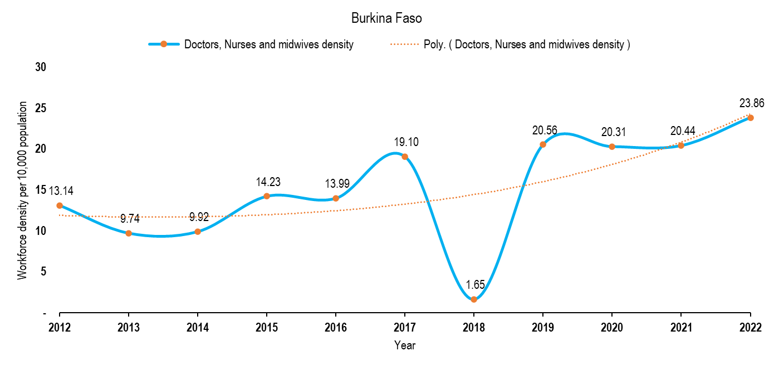

After

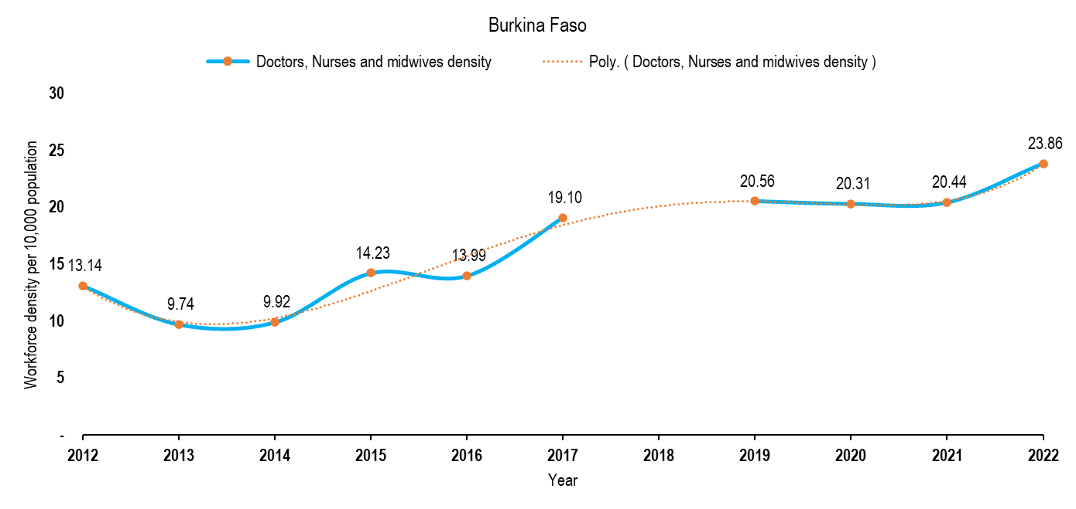

HLMA reports quick review
- Cameroon – data for 2011 available
- Benin – data upto 2016
- Chad – data upto 2015
- Ivory coast – upto 2014
- Ethiopia – 2019, our database has higher figures for that year. Some disparities noted
- Kenya – our database is in line with the report except for 2021 and 22 where our numbers are smaller.
- Lesotho – data for 2019 (comprehensive and useful for the cross section analysis only)
- Mozambique – data is upto date, but the cadres are in Portuguese
- Namibia – no major variations noted
- Rwanda 2018, the selected cadres are within the range of the report
- Seychelles 2019, no major disparities although our data has significantly more nursing professionals.
- Togo 2014, more information on health training
- Uganda 2022, our numbers are slightly higher because of the aggregation, e.g. for nurses, doctors and midwifes. Trends are also given
- Zambia 2023, concentrated more on public sector and so our numbers are higher.
- Zimbabwe, 2015 -2022 the trend are provided. However, our densities for doctors, nurses and midwifes density is higher …. Simply because how we have aggregated the cadres. The Zimbabwe report has disaggregated to finer details.

